Assignment – 3.2
Name – M. Sangeetha
Hall Ticket Number – 2303A52088
Batch - 40
Task Description-1
- Progressive Prompting for Calculator Design: Ask the AI to design a simple calculator program by initially providing only the function name. Gradually enhance the prompt by adding comments and usage examples.
Expected Output-1
- Comparison showing improvement in AI-generated calculator logic and structure.
Promptings:
#“Write a Python function named calculator that performs basic arithmetic operations.”
Code:
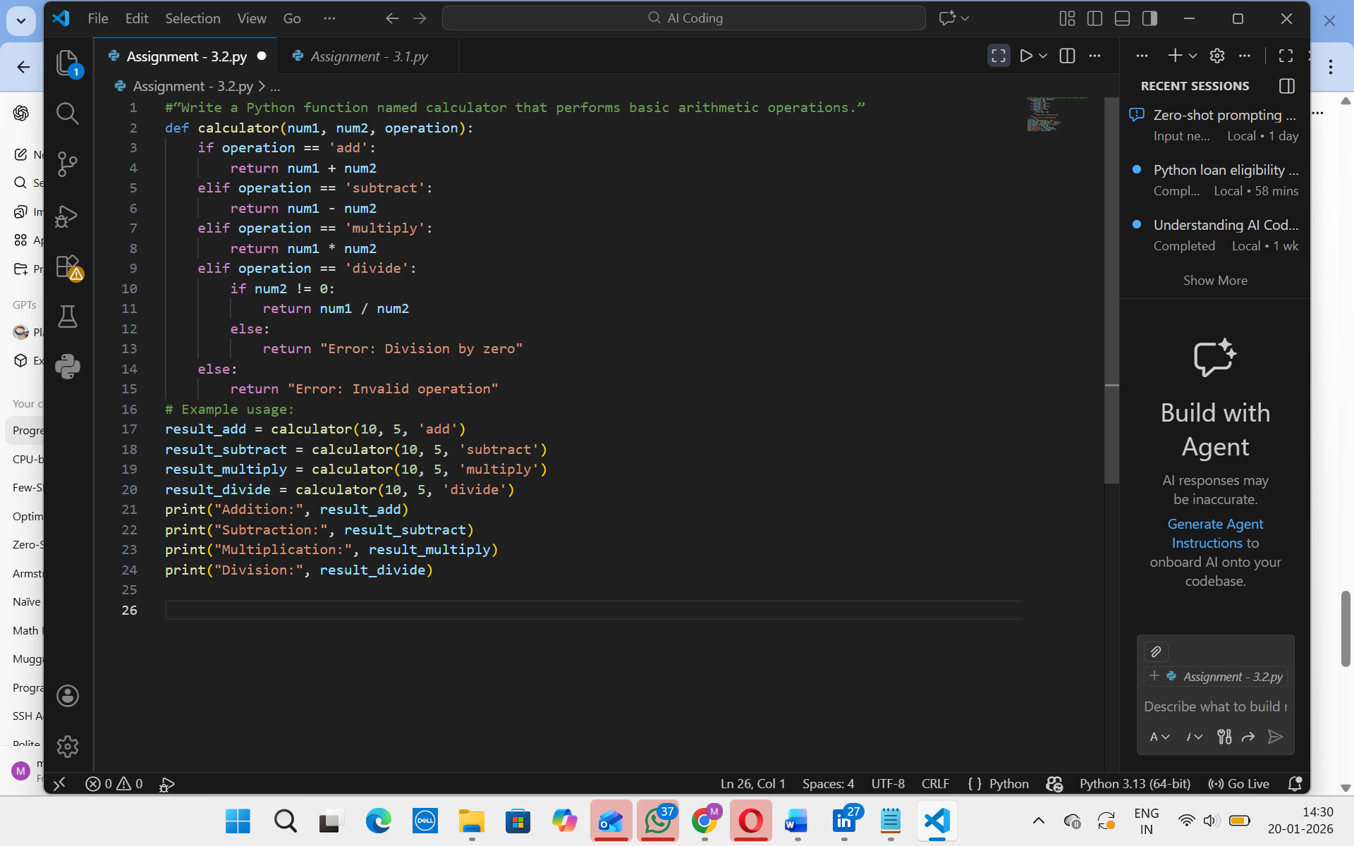
Output:

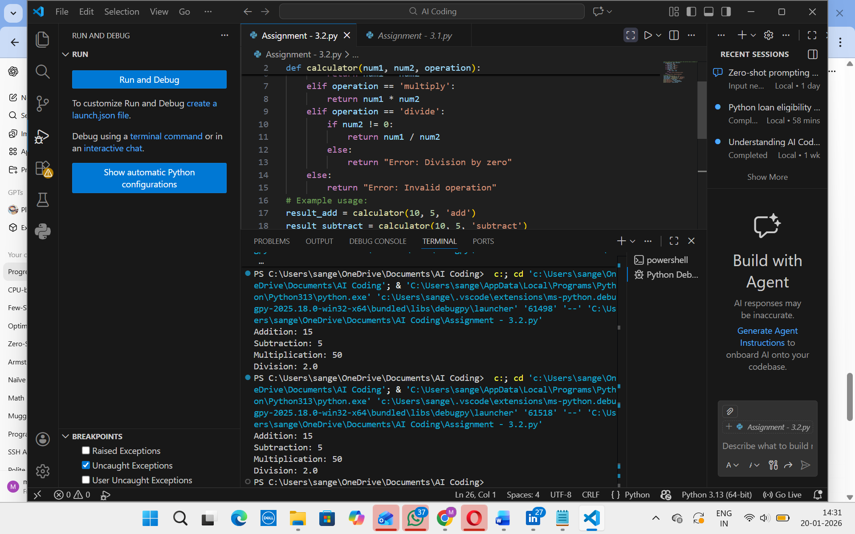
Analysis
- Logic:
  - Covers all basic arithmetic operations.
  - Handles errors like division by zero.
  - Handles invalid operations.
- Structure:
  - Uses a single function → modular, reusable.
  - if-elif-else structure is clear and easy to follow.
- Usability:
  - Can be used with different numbers and operations easily.
  - Returns results rather than printing directly, making it flexible.
Conclusion
Through progressive prompting, the AI-generated calculator evolved from an empty function into a fully functional, reusable, and well-documented program. Each stage of enhancement improved:
- Logic accuracy (error handling, correct arithmetic),
- Structure clarity (comments, functions, docstrings),
- Usability (parameterized design and examples).
Task Description-2
- Refining Prompts for Sorting Logic: Start with a vague prompt for sorting student marks, then refine it to clearly specify sorting order and constraints.
- Promptings:
#“Write a script to sort student marks."
Code:
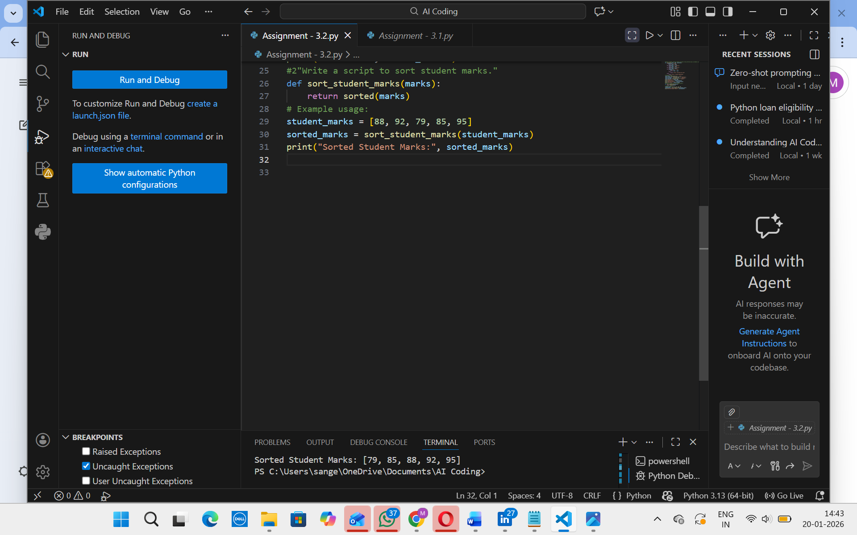
Output:
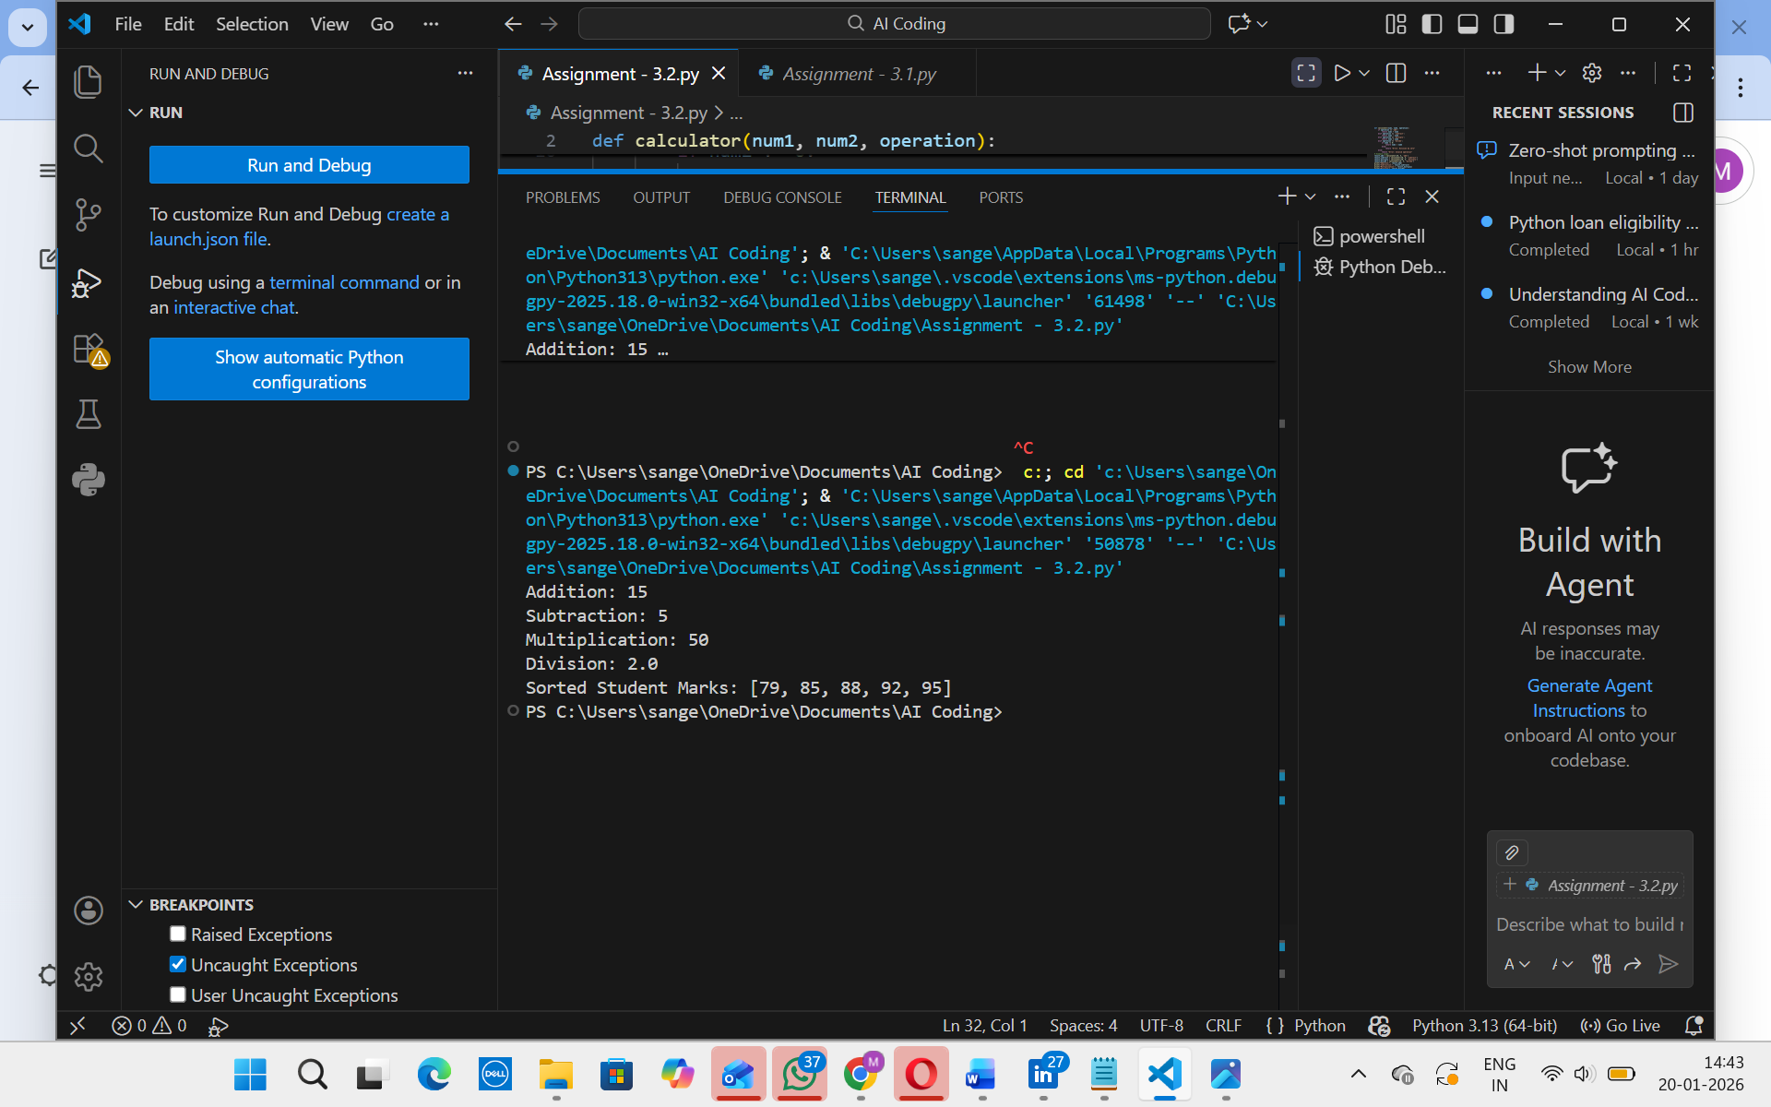

Analysis:
- Define a function sort_student_marks(marks) that takes a list of marks
- Use Python’s built-in sorted() to arrange them in ascending order.
- Call the function with student_marks = [88, 92, 79, 85, 95].
- Print the result → Sorted Student Marks: [79, 85, 88, 92, 95].

Task Description-3
- Few-Shot Prompting for Prime Number Validation: Provide multiple input-output examples for a function that checks whether a number is prime. Observe how few-shot prompting improves correctness.
Expected Output-3
- Improved prime-checking function with better edge-case handling.
Promptings:
#Write a Python function that checks whether a number is prime.
Code:
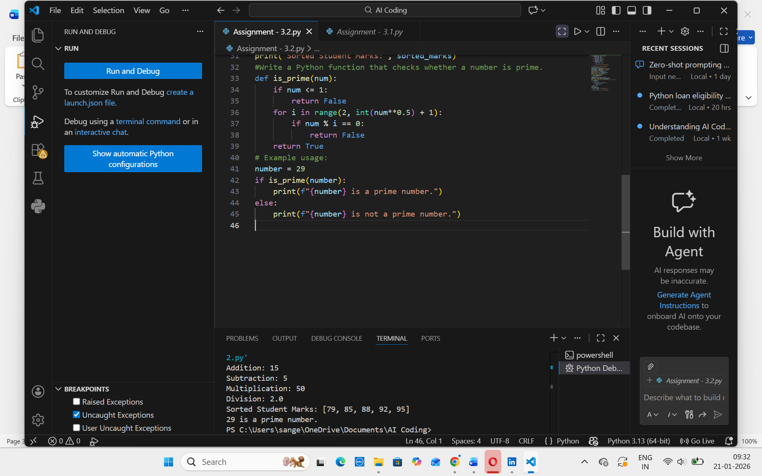
Output:
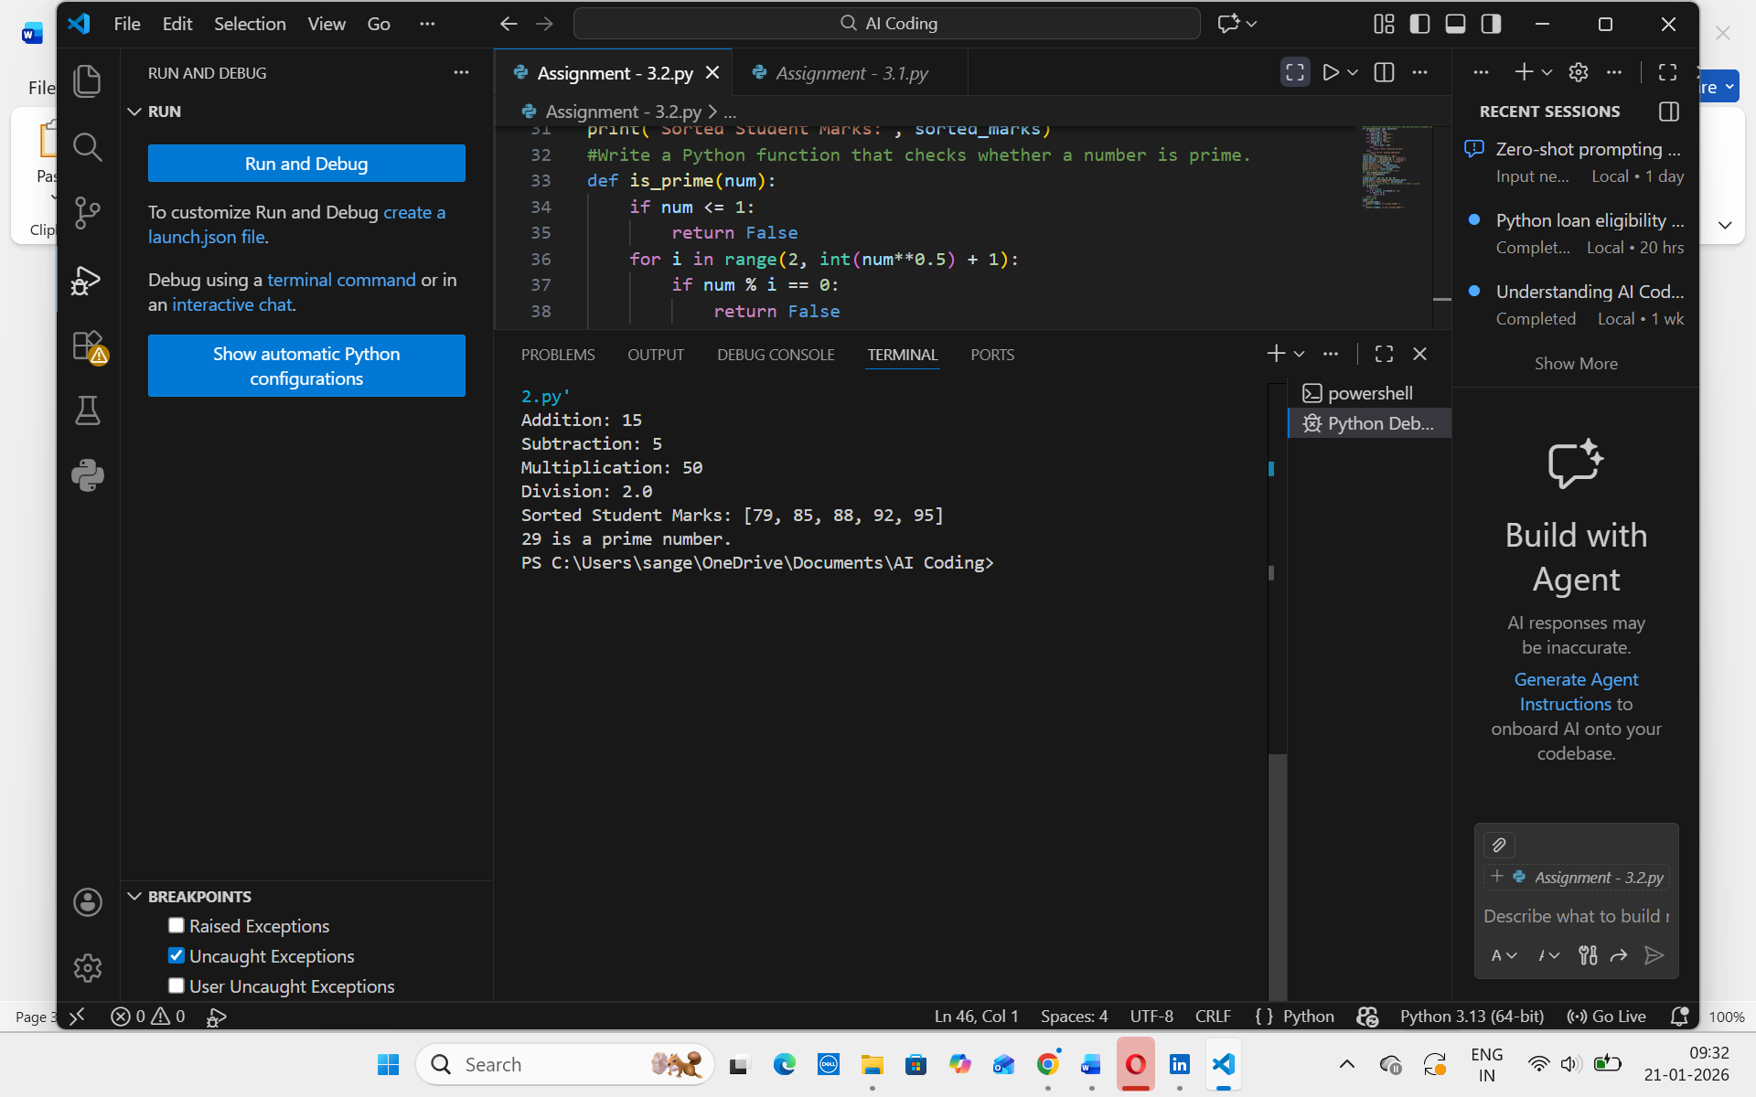
Analysis:
Check if n <= 1 → immediately return "Not Prime" (handles 0,1, negatives).
If n == 2 → return "Prime" (special-case smallest prime).
If n is even (n % 2 == 0) → return "Not Prime" (filters out half of numbers).
Loop i from 3 to int(sqrt(n)) step 2; if n % i == 0 → return "Not Prime".
If no divisor found → return "Prime" (overall time complexity O(√n), space O(1)).
Task Description-4
- Prompt-Guided UI Design for Student Grading System: Create a user interface for a student grading system that calculates total marks, percentage, and grade based on user input.
Expected Output-4
- Well-structured UI code with accurate calculations and clear output display.
Promptings:
#“Make a UI where students can type in their marks.”
#“Create a UI that shows the total marks after entering subject scores.”
#“Design a UI that calculates percentage from the total marks entered.”
#“Build a UI that calculates total marks, percentage, and shows the grade.”
#“Create a neat UI that lets users enter marks, calculates total, percentage, and grade, and displays results clearly.”
import tkinter as tk
Code:
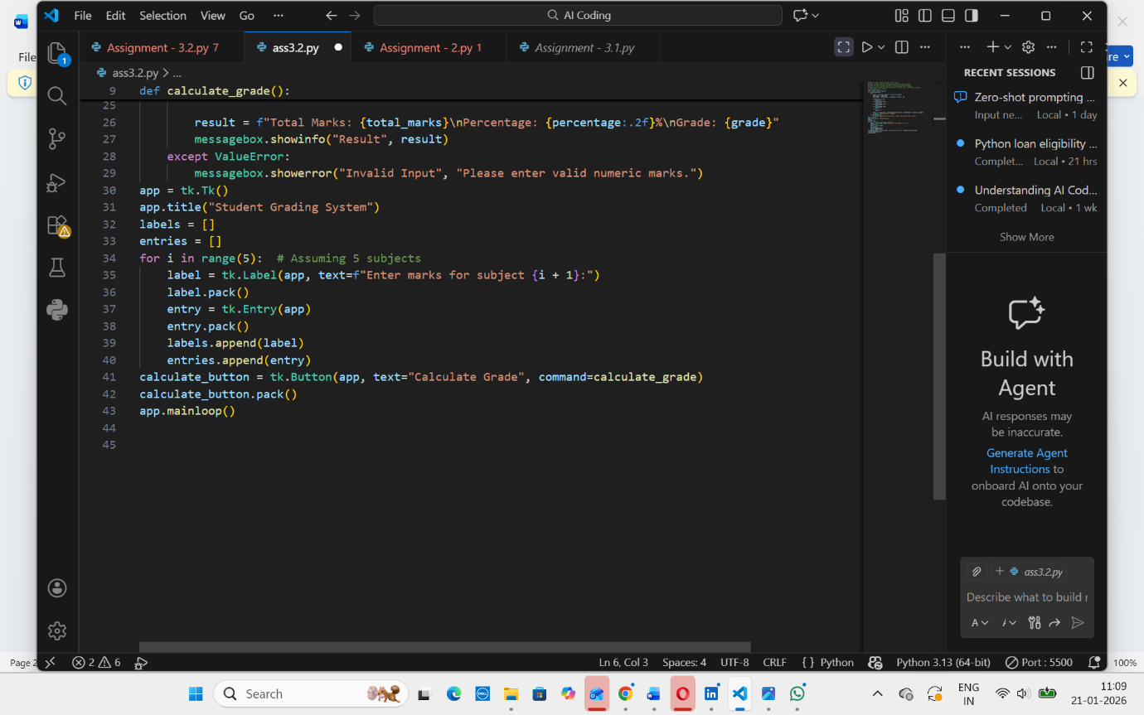

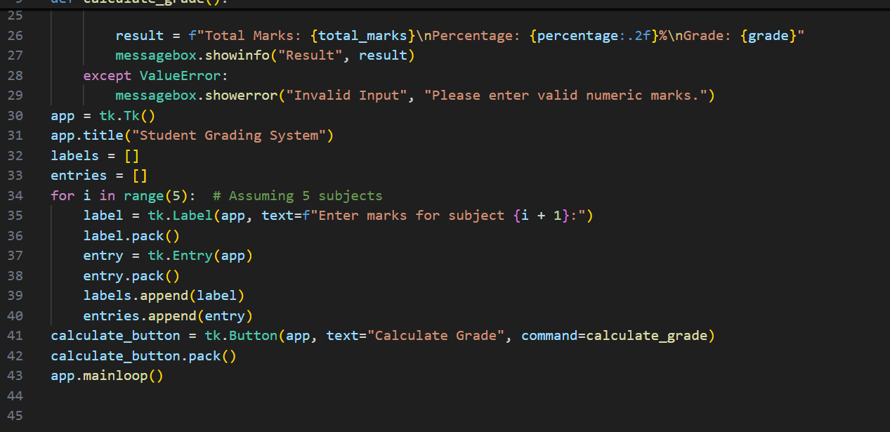
Output:

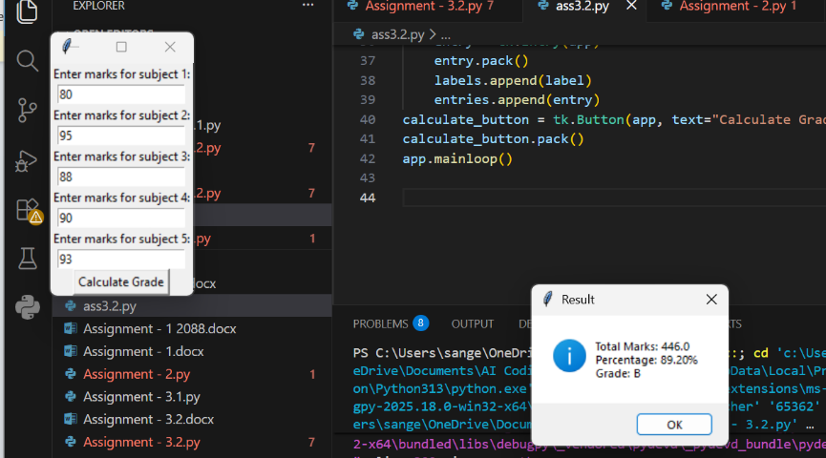

Step-by-Step Analysis
UI Setup → A Tkinter window is created with labels and entry fields for 5 subjects.
Input Handling → Students type marks into entry boxes; values are collected into a list.
Calculation → The program sums marks to get total, then computes percentage based on maximum possible marks.
Grading Logic → Conditional checks assign grades (A–F) depending on percentage thresholds.
Output Display → Results (total, percentage, grade) are shown in a message box; invalid inputs trigger an error message.

Task Description-5
- Analyzing Prompt Specificity in Unit Conversion Functions: Improving a Unit Conversion Function (Kilometers to Miles and Miles to Kilometers) Using Clear Instructions.
Expected Output-5
- Analysis of code quality and accuracy differences across multiple prompt variations.
Promptings:
#Write a function to convert units.”
#“Write a function to convert kilometers to miles.”
#“Write a function that converts kilometers to miles and miles to kilometers.”
#“Write a function that converts kilometers to miles and miles to kilometersusing accurate conversion factors (1 km = 0.621371 miles, 1 mile = 1.60934 km).”
#“Write a function that converts kilometers to miles and miles to kilometers using accurate conversion factors, and display results clearly (e.g., ‘5 km = 3.11 miles’).”
Input:
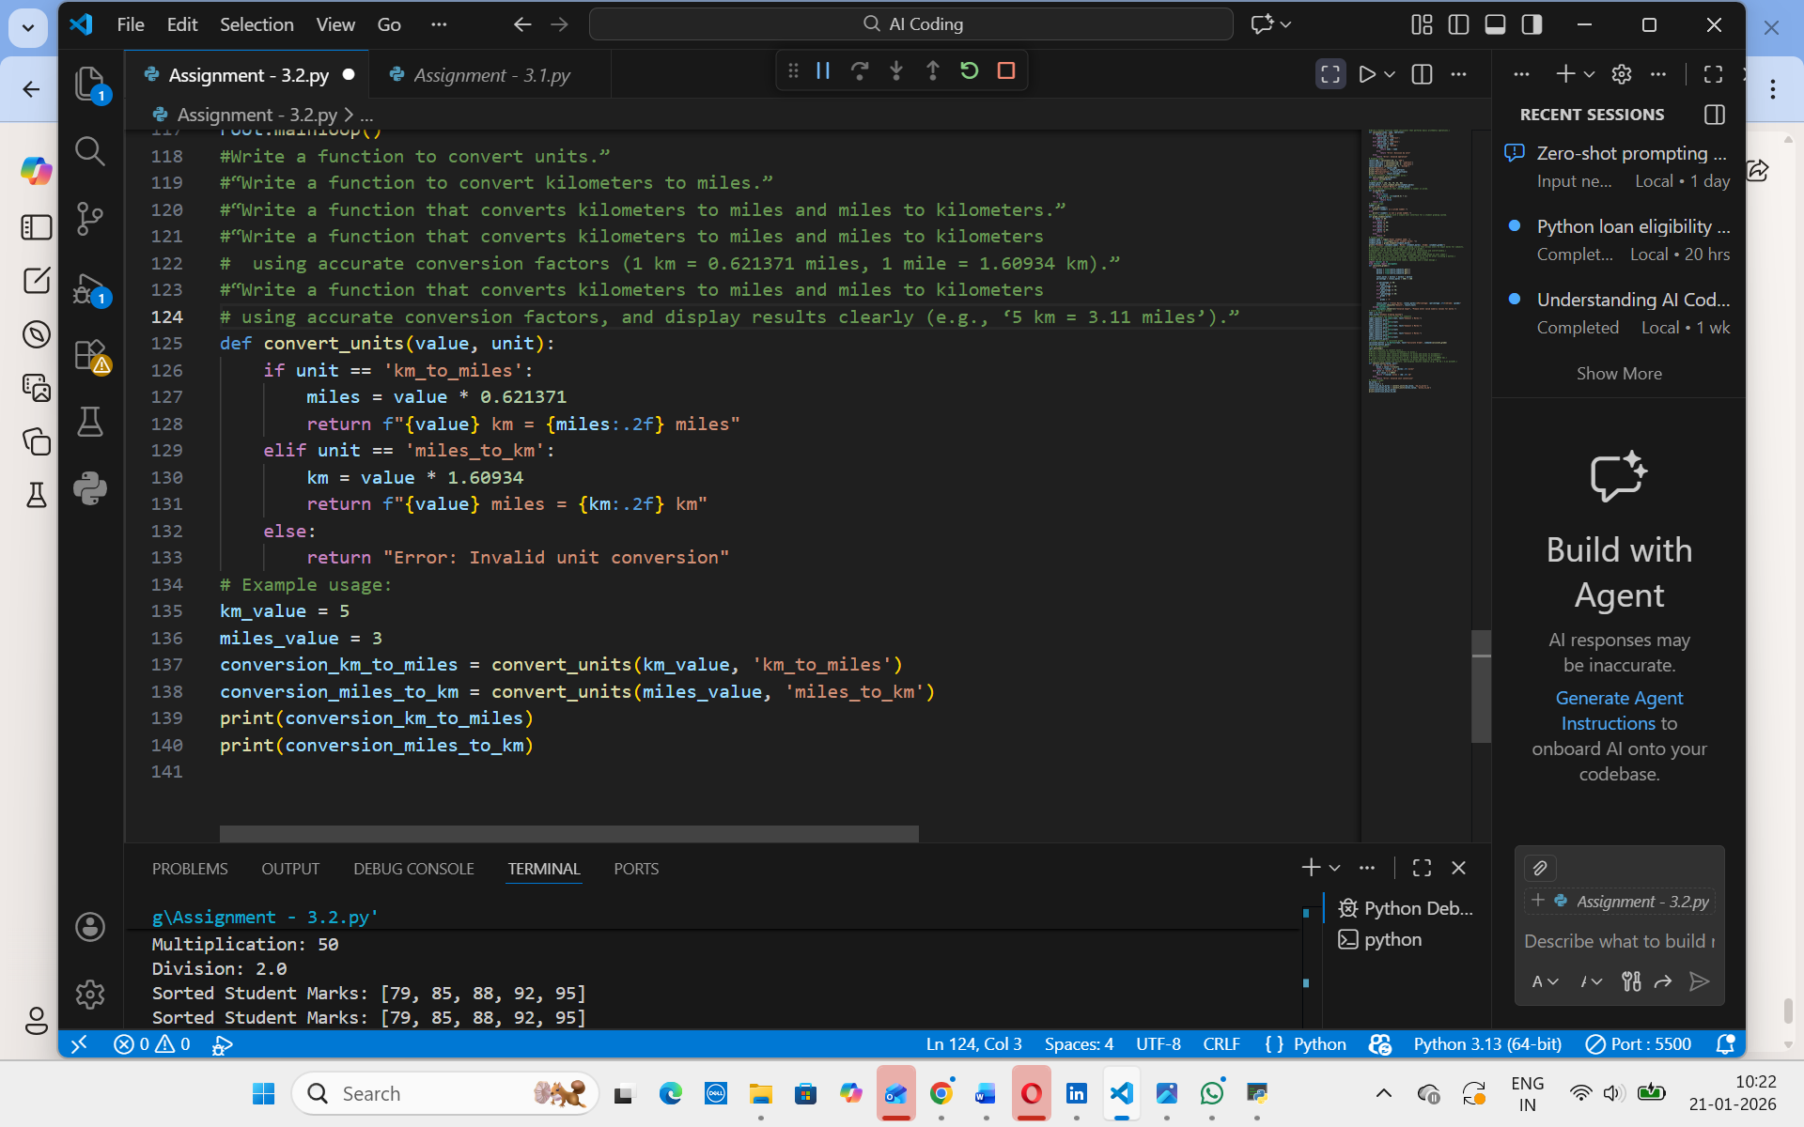

Output:

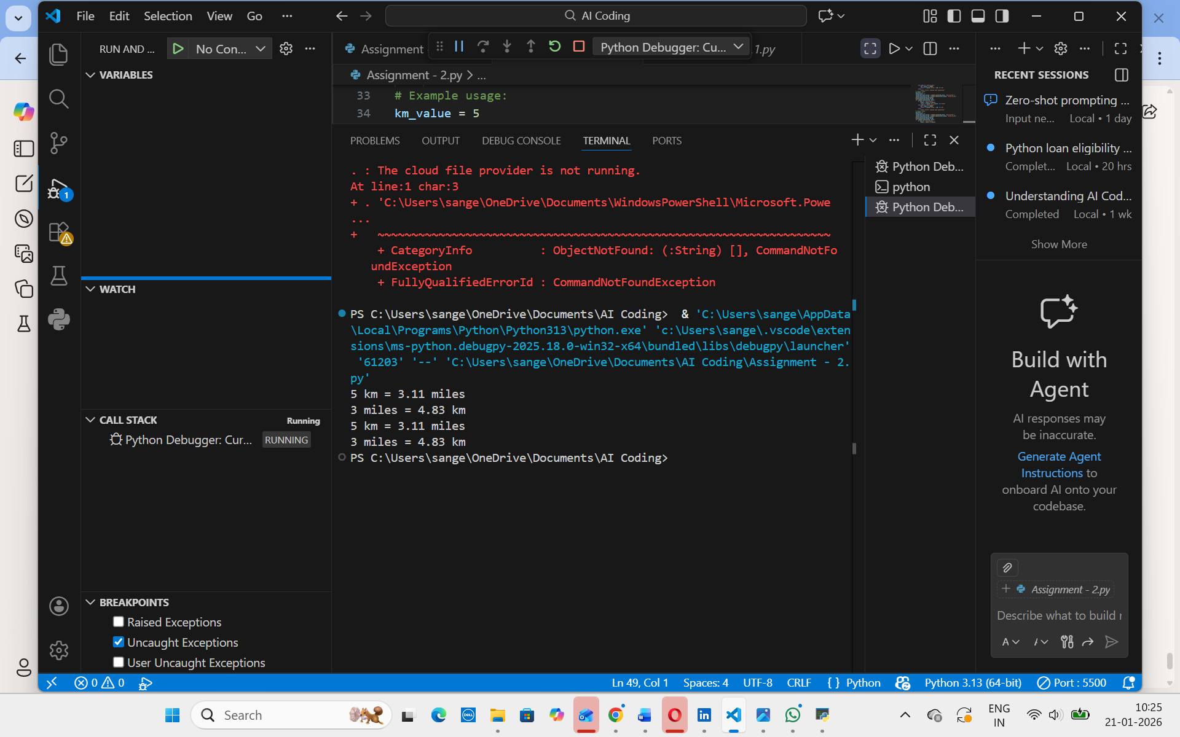

Step-by-Step Analysis
A vague prompt (“convert units”) gives poor, incomplete, and inaccurate code.
A moderately specific prompt (“km → miles”) improves clarity but only covers one direction.
A specific prompt (“km ↔ miles”) adds bidirectional functionality and better structure.
A highly specific prompt with exact factors ensures accuracy and reliability.
A fully specific prompt with clear output formatting produces the best, user-friendly function.

